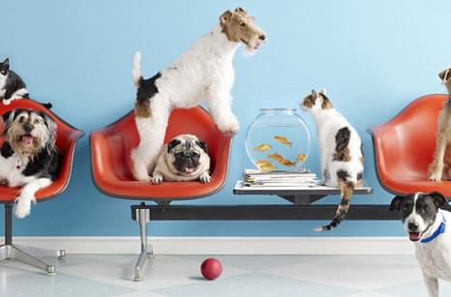

DATABASE FOR Small veterinary offices

DATABASE MANAGEMENT SYSTEMS

PROJECT PREPARED BY:

Charles Mullins

Joseph Sadler

Melvin gaye

Christopher Ratliff

Spring 2017

Table of Contents

Team Members 2

Introduction of Small Veterinary Office Database 2

Small Veterinary Office Profile 3

Small Veterinary Office Description 3

User Requirements 3

c. Expected Database Queries 4

Entity Relationship Diagram 5

Assumptions: 5

Gantt Chart 5

# **Team Members**

Charles Mullins

Joseph Sadler

Melvin Gaye

Christopher Ratliff

# **Introduction of Small Veterinary Office Database**

The development of a database project for a general small veterinary clinic began in April of 2017. It is being developed to help the small veterinary clinics keep track of all pet information, owner information, and bills. In addition, it helps to manage all medicine prescriptions and refills as well as appointments. This will improve efficiency of the office. The database will help in finding and tracking records more easily to help save both money and time for the office.

A team of four students are currently working on this project. The database and user interface will be made in NetBeans. This project is currently being done for the Database Management Systems class and it incorporates the database and software knowledge that the students have and will be learning throughout the semester.

# **Small Veterinary Office Profile**

Small Veterinary offices are like a doctor’s office for animals. The purpose of these offices is to provide medicine and general medical care for pets. This is a necessity for all pet owners to have, and a database that makes the office more efficient is only going to be a benefit for all involved. Any pet will eventually run into health problems that need attention throughout its entire life. The veterinary offices will ensure the continued good health of pets.

Small veterinary offices are available everywhere. Veterinarians that work there have gone through around 10 years of university and veterinary school education in order to work at these offices.

As the number of customers continues to grow, it becomes increasingly important to keep track and manage what happens in the office. Therefore, small veterinary offices would benefit from this database to keep track of all these different areas.

# **Small Veterinary Office Description**

**How Small Vet offices Work**

In most offices, employees have different responsibilities and roles in the office: Veterinarian, Vet tech, and interns. The veterinarian oversees everything and specializes in diagnosing pet illnesses, prescribing medicine and refills, and surgeries. The vet techs assist the vet in these tasks along with the interns. Appointments are made by the vet techs along with handling the billing of the customers.

The database is needed to assist keeping track of all of this. Appointments kept in a database would be much more organized and efficient than a physical calendar. It is a lot easier to keep track of prescriptions and refills in a database, as well as keep a log of pet and owner information.

# **User Requirements**

**a. Process Modelling Requirements**

Small Veterinarian offices have different employee levels. Each employee has certain information such as Name (First Name, Last Name), Address, Phone Number, license number, years of experience, and a unique ID. The employees are categorized into Veterinarian, Vet tech/regular employee or intern. Each Pet has an ID, Name, Sex, Species, and age. Each owner has information such as Name (First name, Last Name), Address, Phone Number, Owner ID and a unique user ID. Each pet belongs to an owner. A veterinarian can be responsible for many owner’s pets. An owner can have multiple pets. A pet can have multiple medicines and medicine records. An owner is also responsible for the bills to pay for the care of their pets. A bill consists of the balance, total amount, due date, and has a unique ID. The database itself will have many different users (consisting of those already listed like the veterinarian and owners) and each user will have a different role in the database. Users will have a username and password to access the database.

**b. Data Modelling Requirements**

Allow users different permissions within the database depending on who they are.

1. Allow veterinarian to manage prescriptions and refills
2. Allow veterinarian to view and create appointments
3. Allow veterinarian same permissions as employees
4. Allow employees to create and view appointments
5. Allow employees to update customer bills
6. Allow employees to update pet information
7. Allow owners to view appointments and bills and pet information

# **c. Expected Database Queries**

1. View Bills.
2. View pet information for all owners
3. View pet information for one owner
4. View owner information
5. Update pet information
6. Update bills
7. Update appointment times

# 

# **Entity Relationship Diagram**

# **Assumptions:**

* Each Owner will have one or more pet
* Each Veterinarian will be responsible for multiple owners
* Owners will have bills
* 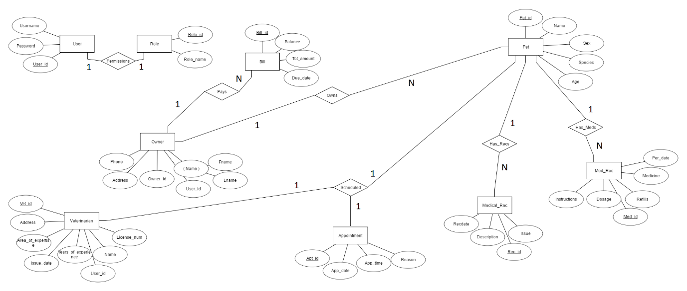Pets will have medical records

# 

# 

# **Task List**

|  |  |  |  |
| --- | --- | --- | --- |
| Task | Duration | Start | Finish |
| Project proposal | 4 days | Mar 14 2017 | Mar 18 2017 |
| ER Diagram rough draft | 4 days | Mar 18 2017 | Mar 22 2017 |
| Schema diagram rough draft | 2 days | Apr 21 2017 | Apr 23 2017 |
| Created initial MySQL database scripts | 3 days | Apr 27 2017 | Apr 30 2017 |
| Finalized ER Diagram | 14 days | May 3 2017 | May 17 2017 |
| Finalized Schema | 14 days | May 3 2017 | May 17 2017 |
| Finalized MySQL scripts | 14 days | May 3 2017 | May 17 2017 |
| Application creation | 14 days | May 3 2017 | May 17 2017 |
| Tutorials/Manuals | 2 days | May 17 2017 | May 19 2017 |
| Software report | 2 days | May 17 2017 | May 19 2017 |

# **Gantt Chart**

